1. What is the total amount of petrol in volume sold by every distributor?

Since we want volume sold by each distributor group by district name and sum volume out to get the total amount of petrol sold in volume

1. Which are the top 10 distributors ID's for selling petrol? Also display the amount of petrol sold in volume.

Since we want volume sold by each distributor id, group by district id and sum volume out to get the total amount of petrol sold in volume and then sort by descending then limit by 10 to get top 10;

3. List 10 years where consumption of petrol is more with the distributer id who sold it.

Since we want 10 years where consumption is more with the district id , group by id year then for each i will find volume consumed by subtracting volume in – volume out then order by it descending to get top 10 and i will display the year

1. Find the distributer name who sold petrol in least amount.

Group by district name and sum volume out to get the total amount of petrol sold in volume and limit by 1

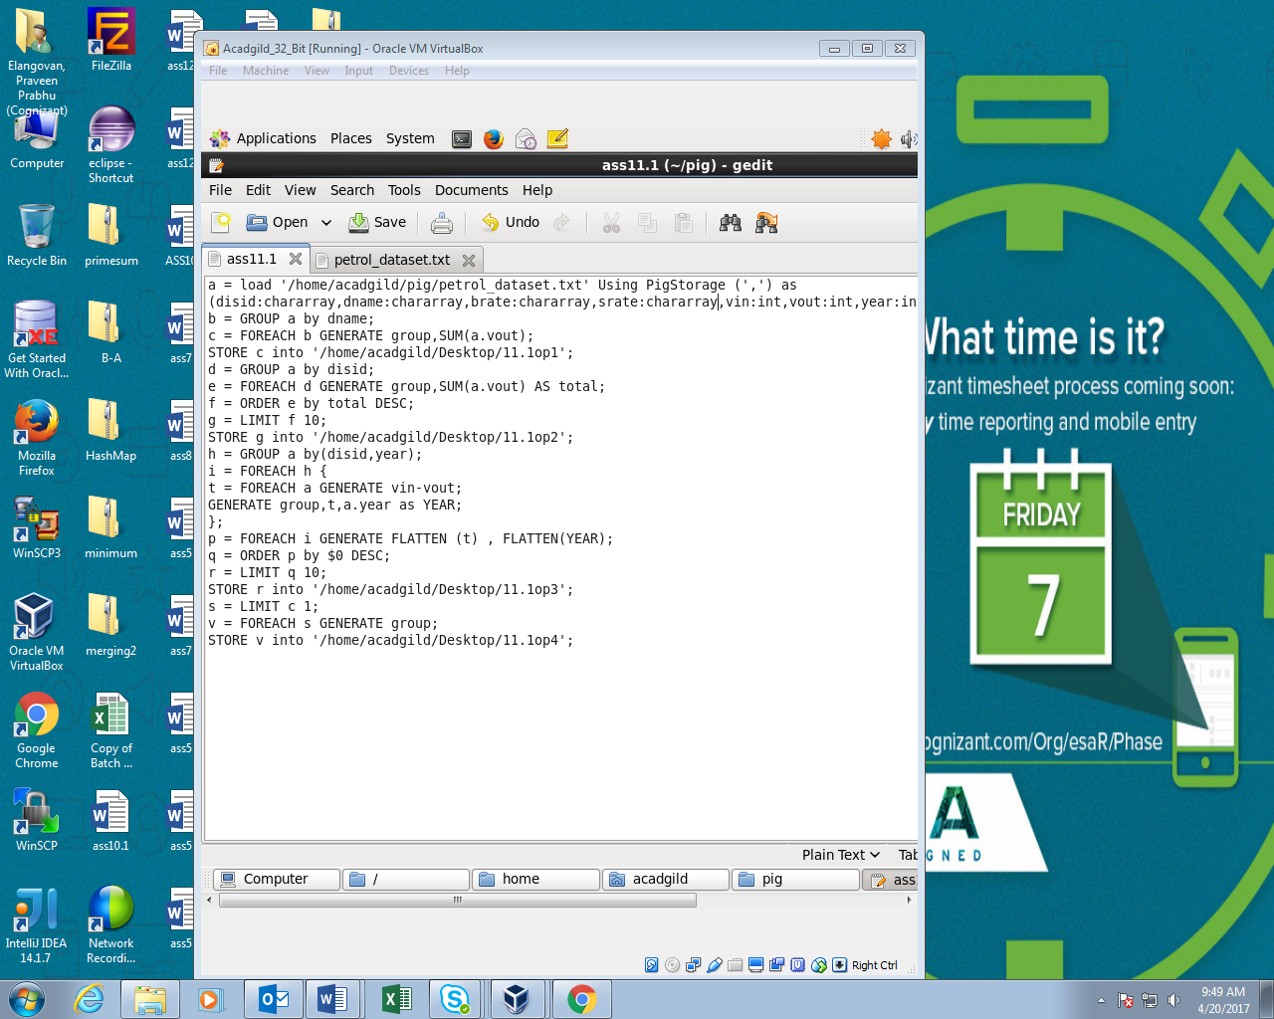

Running PIG script:

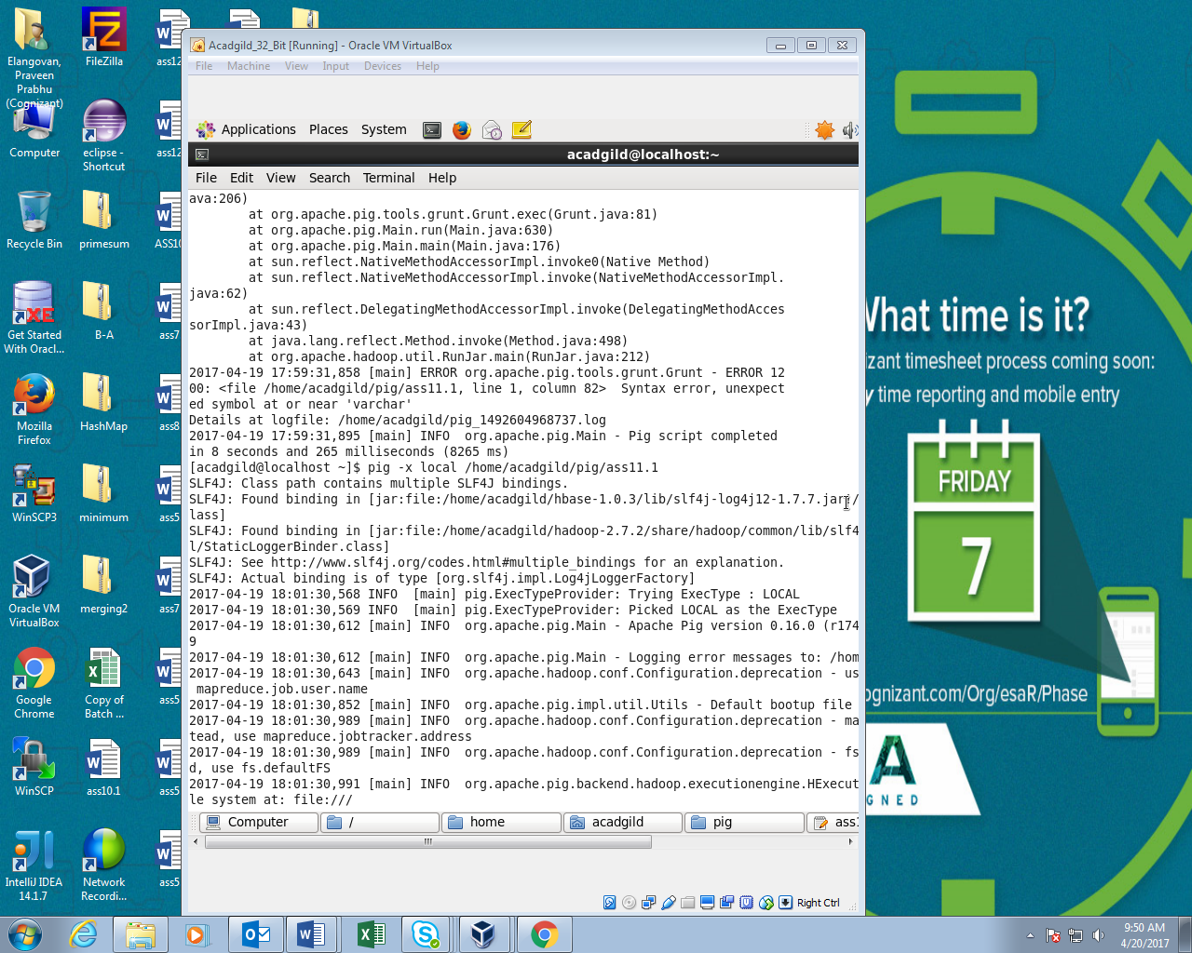

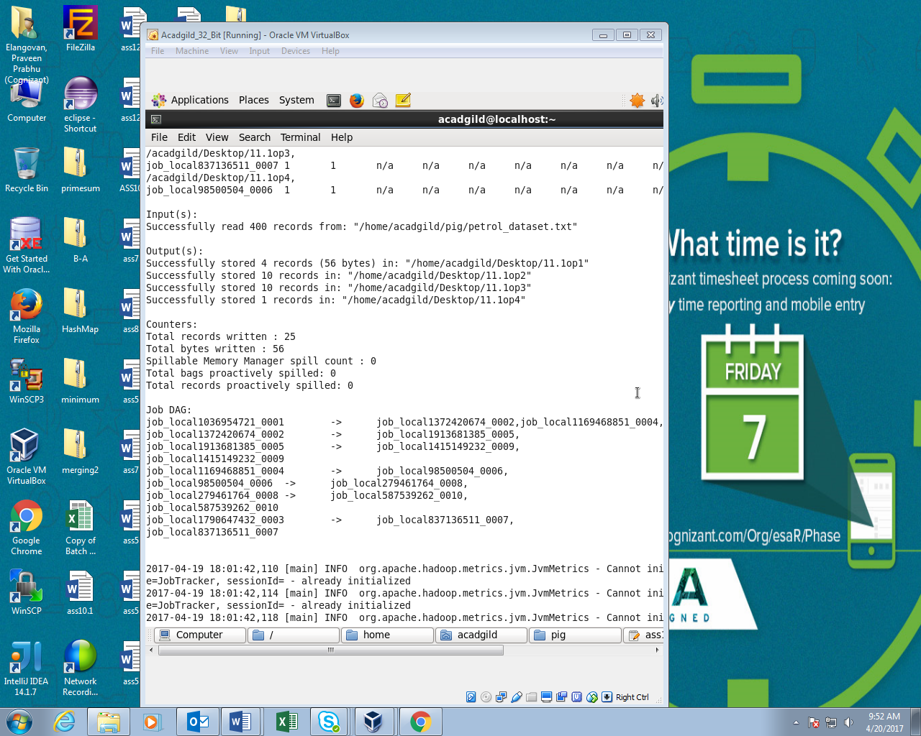

OUTPUT:

